Step 1. RIP
- Binary copy (ripping) of the CF or CF MINIX partition to a windows binary file
- Cnsistency check and repair tool of the MINIX filesystem
- Unpack MINIX filesystem to any windows folder

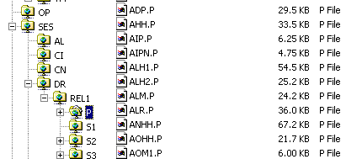

Compact Flash
1
. . .
MINIX Partitions
a) Rip binary
MINIX Partition
Binary Image in File
Windows 98/NT/2K/XP
c) Unpack
To Win. folder
b) fsck (check consistency & repair)
At this point you can:
- unpack CF to more than one folder
- edit unpacked folder with subfolders and do whatever you want on windows
When satisfied with the folder & data content, proceede to step 2.
Note: You do not need Step 1 to create CF or CF partition. You can directly proceed to step 2!

Step 2. BURN
- Format MINIX partition (in the binary image)
- Pack any windows folder into MINIX filesystem binary image
- Burn binary image into CF partition

Compact Flash
21
. . .
MINIX Partitions
c) Burn binary
MINIX Partition
Binary Image in File
Windows 98/NT/2K/XP
b) Pack from Win. folder
a) Format MINIX Partition

